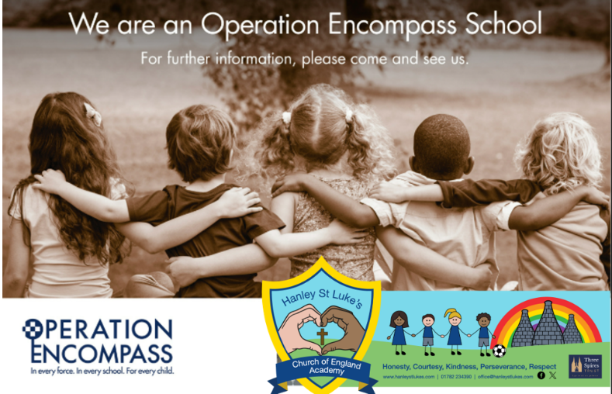

Operation Encompass
Hanley St Luke’s Church of England Primary Academy is an Operation Encompass school.
Operation Encompass is a partnership between the police and schools that ensures schools are informed when a child has been affected by a domestic abuse incident.
Where appropriate, the police share information with our Designated Safeguarding Lead (DSL) so that we can provide discreet, timely, sensitive and appropriate support to the child in school.
All information is treated sensitively and confidentially in line with our safeguarding procedures.

