🌈 Are You a Young Carer? 🌈

Come and speak to us if you think you may be a young carer, or if you know someone who is.
You might be a young carer if you help look after a family member who:
💜 Has a disability
💙 Has an illness or long-term health condition
💚 Has mental health difficulties
💛 Needs extra support at home

We are here to listen, support and help.
📍 Speak to your Young Carer Leads in school-
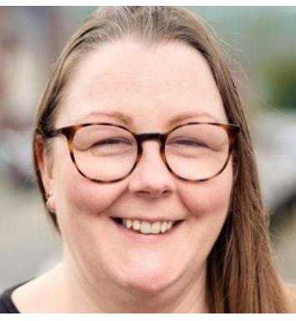
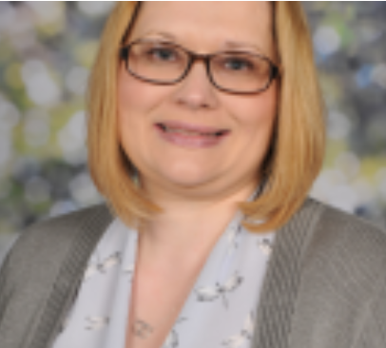
Miss Facey and Mrs Cartwright-Davies
office@hanleystlukes.com 01782 234390

You are not alone. 🌈

