Autumn 1  8 weeks | Autumn 2  7 weeks | Spring 1  7 weeks | Spring 2  5 weeks | Summer 1  6 weeks | Summer 2  7 weeks
Fabulous Friends  People who help us | Let’s Celebrate | Bruno Bear Travel with me | Superhero’s in the  Super market | Under the Sea | Twisted Tales
Books
The Colour Monster  Emergency  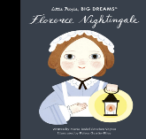  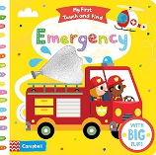  Florence nightingale  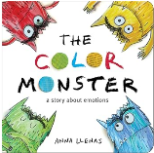 | A very noisy Christmas  Binny’s Diwali  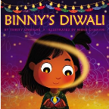  The Great Race The Quiet little firework  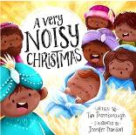  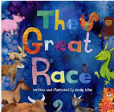  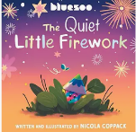 | Meerkat Mail  We’re going on a bear hunt  Monkey Puzzle  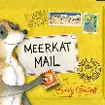  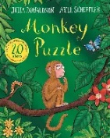  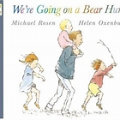 | Supertato  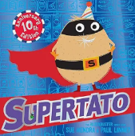 | 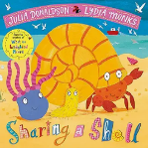  Sharing a shell  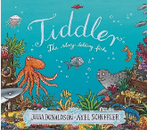  Tiddler | The True story of the 3 little pigs  Goldilocks and just one bear  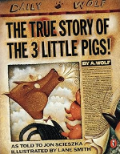  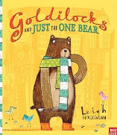
Educational visits
Emergency Service Visit  Local visit –  Walk around the local area Picnic in the Park  (Northwood) | Santa Visit  Local Visit –  Visit the post office/post box to post letters to Santa  Plan a route for Santa – FS2 focus on using a map  Seasonal changes - Winter | Cultural Day  Local Visit –  Similarities and differences between our homes  What is in our local area? | Visit the supermarket  Local Visit –  Seasonal changes - Spring  Visit Hanley Market | Blue Planet/Alton Towers  Local Visit –  Library visit | Local Visit –  Visit to the local park  Identifying similarities and differences  Seasonal changes - Summer
Writing
Name writing  Mark- making  Letter formation  Squiggle | Name writing  Squiggle  CVC words  Letter formation | Name writing  Squiggle  CVC words  Letter formation | Name writing  Squiggle  Writing short phrases  Letter formation | Name writing  Squiggle  I can see writing  Letter formation | Name writing  Squiggle  Sentence starters writing  Letter formation
Oracy
Children share something they’ve enjoyed doing with a friend this half term. | Christmas performance | Where Would You Go?  A Magic Carpet Adventure  Children sit on a "magic carpet" (blanket or mat) and imagine flying anywhere.  Each child shares:  “I would go to…”  “Because I want to see…” | Hot Seat Supertato  Children think of questions they would like to ask Supertato | Sea Story Builders  Begin with: “One day, I went diving and found…”  Go around the circle with each child adding a sentence.  Could be recorded and played back, or acted out with props. | The real story of the three little pig’s courtroom debate
Career links
Police officer  Fire Fighter  Teacher | Party organiser  Priest  Postman | Pilot  Travel agent  Train Driver | Super market worker  Green Grocer  Baker | Marine Biologist | Detective  Judge
Maths
Subitising  Counting, cardinality and ordinality  Composition | Subitising  Counting, cardinality and ordinality  Composition | Subitising  Counting, cardinality and ordinality  Composition | Subitising  Counting, cardinality and ordinality  Composition | Subitising  Counting, cardinality and ordinality  Composition | Subitising  Counting, cardinality and ordinality  Composition
Links to KS1 Curriculum.
Links with KS1  Year 1 – History – Toys and Trains  Year 1 – Geography – Train Journeys  Year 1 – Science - Seasons | Links with KS1  Year 1 – Science – Seasons  Year 1 and Year 2 – R.E – Celebrations/ Baptism/Weddings | Links with KS1  Year 1 – Geography – Local Area | Links with KS1  Year 1 – Science – Seasons  Year 1 – Science – Animals including humans  Year 2 – Science – Living things and their habitats | Links with KS1  Year 2 – Geography – Australia  Year 3 – Science – Animals  Year 1 and 2 – D&T – Food  Year 1 and 2 – Science – Plants | Links with KS1  Year 1 – Science – Seasons  Year 2 – Geography – Poles Apart  Year 2 – Geography – The World and Me
Music, Art, Geography, History, PSHE and D&T are taught through topics over the year.

