

Hello and Welcome to 2S!

2025-2026
Meet your new teacher and support staff, We can’t wait to see you.

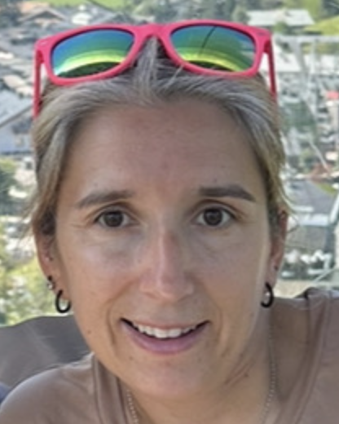
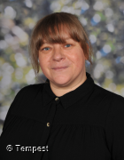

Mrs Farnell
Miss Jennings

This is our new classroom;
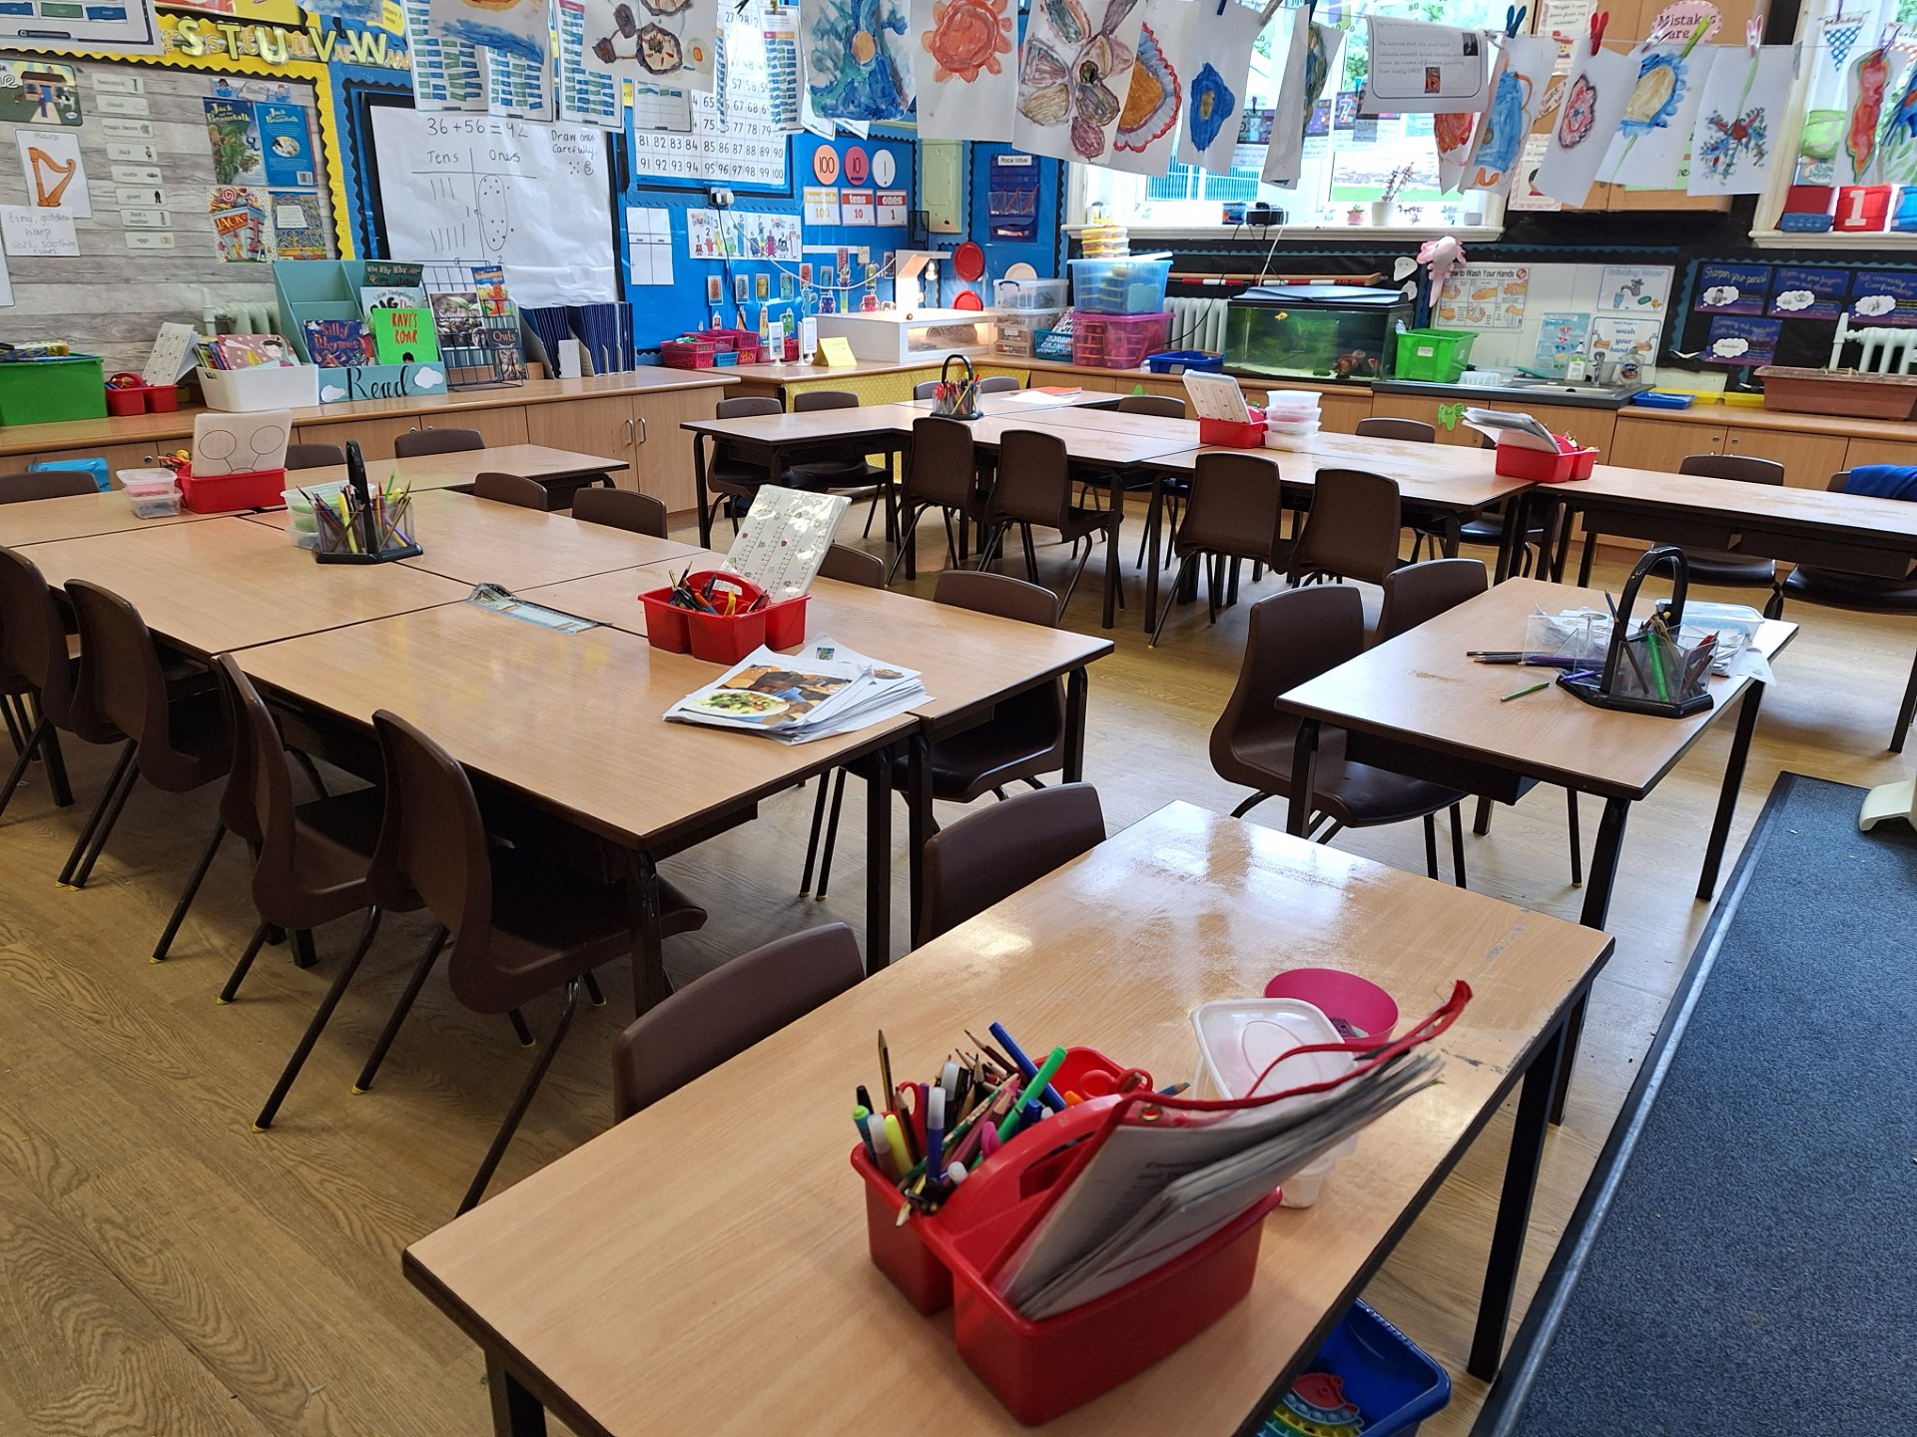

Welcome to 2S. We can’t wait to welcome you to Year 2. We love to learn and have fun along the way! We have lots of exciting things planned this year and we look forward to meeting you all. See you soon!

In year 2, we are hoping to go on a variety of trips and walks to local places to enhance our learning. We already have a trip to the farm booked in!

We have some fun and interesting topics to study in Year 2, including Animals and their Offspring, The Gingerbread Man, The Great Fire of London and Jack and the Beanstalk.

In year 2, we come to school in our PE kit on PE days.
We love to sing in Year 2!

